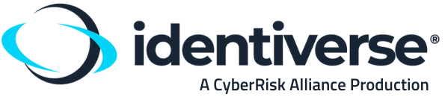

(Copy, paste and edit to obtain approval to attend Identiverse)

Dear <<Insert Name>>,

I would like to request your approval to attend an industry event, focused on identity and security called Identiverse. The 2024 event will be held May 28 - 31, 2024 at the ARIA Resort & Casino in Las Vegas, NV.

Identiverse convenes the brightest minds across the identity and security industry. Executives from industry-leading companies will be headlining the event—introducing the newest trends and best practices in cloud identity management.

Over the span of 4 days, 2,500+ identity security professionals and experts will gather to participate in over 70+ hours of valuable programming and content including insightful keynotes, hands-on masterclasses, and other informative sessions. Identiverse is the best opportunity this year to meet in one location with identity, cloud and security experts from around the globe.

At Identiverse, I plan on spending my time identifying solutions and strengthening our identity and access management (IAM) best practices in the following areas:
1. xxx
2. yyy
3. zzz

The organizers at Identiverse are offering multiple pass options, and I would like to invest in the ________ pass as it will give me the best experience. The Identiverse team has also negotiated a discounted rate at the venue’s hotel when booking before the deadline of Thursday, April 24, 2024. With this said, I appreciate your immediate attention to my request.

Please let me know if I can commit to attending this valuable event. Thank you for the consideration.
Regards,
<<Your Name>>

